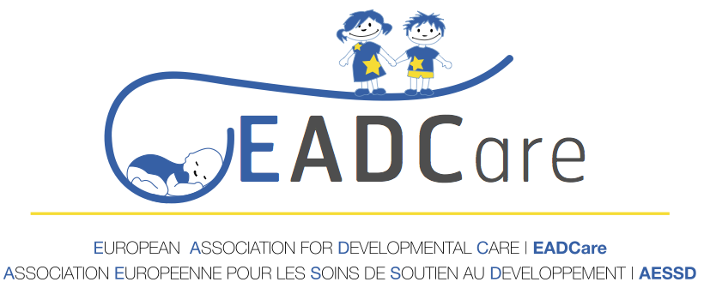
9TH SYMPOSIUM
DEVELOPMENTAL CARE IN NEONATOLOGY AND PEDIATRICS
24-25 OCTOBER 2019
SAN LORENZO DE EL ESCORIAL, MADRID, SPAIN

REGISTRATION FORM
DEADLINE FOR REGISTARTION 15TH OCTOBER 2019
SEND FORM TO: MADRID2019@EADCARE.ORG

NAME: SURNAME:
EMAIL: @
AFFILIATION:
ADDRESS:
CITY: COUNTRY
PROFESSION:

OPTION1 (1 NIGHT) : 590 € ☐
OPTION 2 (2 NIGHTS) : 770 € ☐
OPTION 3 without accommodation: 450 € ☐

PAYMENT DATE :

Please, once you have made the payment, send an email to: madrid2019@eadcare.org with the two attached documents: the registration form and the bank transfer document.

